**PSG COLLEGE OF TECHNOLOGY, COIMBATORE – 641 004**

**Department of Applied Mathematics and Computational Sciences**

**MSc SOFTWARE SYSTEMS – Semester IV**

**20XW48 – Web Designing Lab**

**PROBLEM SHEET on Frames and menus**

* Swetha Muralidharan
* 20pw35

Create frames and menus using the following models.

1. **Model 1**

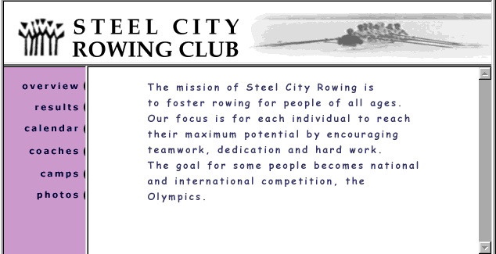

|  |  |
| --- | --- |
| <html>  <head>  <style>  div{ display :flex ; height :100% }  </style>  <title> Steel City Rowing Club </title>  </head>  <body>  <iframe src="content1.html" height=25% width=100% title="Banner"> </iframe>  <div>  <iframe src="content2.html" height="75%" width="20%" title="menu"></iframe>  <iframe src="content3.html" width="80%" height="75%" title="content"></iframe>  </div>  </body>  </html> | <html>  <head>  <style>  h1  {  font-size: 50px;  font-family: Cambria, Cochin, Georgia, Times, 'Times New Roman', serif;  }  body  {  display : flex ;  justify-content : space-evenly; }  </style>  </head>  <body>  <img src="logo.png" >  <h1> STEEL CITY <br> ROWING CLUB </h1>  <img src="boat.jpg" >  </body>  </html> |
| <html>  <head>  <style>  body {  background-color:plum;  text-align:right; }  nav  {  font-family: 'Times New Roman', Times, serif;  font-size: 50px;  display:block;  align-content :right;  }  </style>  </head>  <body><nav>  <ul>  <a href ="content1.html" target="content"> Overview </a>  <br>  <a href ="content2.html" target="_blank"> Results</a> <br>  <a href ="content3.html" target="_self"> Calender </a> <br>  <a href ="content1.html" target="_parent"> Coaches </a> <br>  <a href ="content2.html" target="_top"> Camps </a> <br>  <a href ="content3.html" target="content"> Photos </a> <br>  </ul>  </nav>  </body>  </html> | <html>  <head>  <style>  body  {  text-align: justify;  font-family: Arial, Helvetica, sans-serif;  font-size: 45px;  padding-left :15%;  padding-top :5%  }  </style>  </head>  <body>  <p>  <div id="#overview">The mission of Steel City Rowing is <br>  to foster rowing for people of all ages . <br>  Our focus is for each individual to reach <br> their  maximum potential by encouraging <br>teamwork ,  dedication and hardwork .<br> The goal for some peopl becomes national <br>  intenational competition , the <br>  olympics.  </div>  </p>  </body>  </html> |

|  |
| --- |
|  |

1. **Model 2**

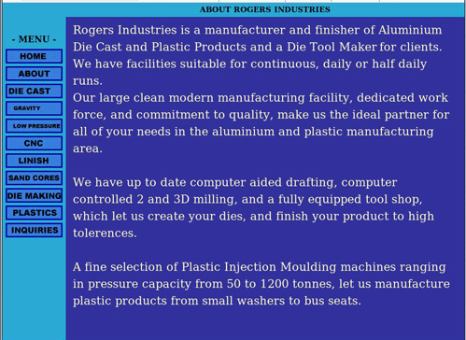

|  |
| --- |
| <html>  <head>  <style>  body  {  background-color:skyblue;  }  h2  {  text-align:center;  }  </style>  </head>  <body>  <h2> ABOUT ROGERS INDUSTRIES</h2>  <iframe src="2.1.html" width="20%" height="90%"> </iframe>  <iframe src="2.2.html" width="79%" height="90%"> </iframe>  </body>  </html> |
| <html>  <head>  <style>  body  {  text-align :center;  }  nav  {  text-align: center;  font-size : 35px;  }  button  {  width :60%;  height :8%;  background-color :navy;  text-align :center;  color:white;  }  a  {  color:white;  }  </style>  </head>  <body>  <form>  <h3> - MENU - </h3>  <nav>  <button> <a href ="2.1.html" target="content"> HOME </a> </button> <br>  <button> <a href ="2.2.html" target="content"> ABOUT </a> </button> <br>  <button> <a href ="2.1.html" target="content"> DIE CAST </a> </button> <br>  <button> <a href ="2.2.html" target="content"> GRAVITY </a> </button> <br>  <button> <a href ="2.1.html" target="content"> LOW PRESSURE </a> </button> <br>  <button> <a href ="2.2.html" target="content"> CNC </a> </button> <br>  <button> <a href ="2.1.html" target="content"> LINISH </a> </button> <br>  <button> <a href ="2.2.html" target="content"> SAND CORES </a> </button> <br>  <button> <a href ="2.1.html" target="content"> DIE MAKING </a> </button> <br>  <button> <a href ="2.2.html" target="content"> PLASTICS </a> </button> <br>  <button> <a href ="2.1.html" target="content"> INQUIRES </a> </button> <br>  </nav>  </form>  </body>  </html> |
| <html>  <head>  </head>  <style>  body  {  background-color:navy;  }  p  {  text-align:justify;  color:white;  font-family:Times New roman;  font-size:25px;  }  </style>  </head>  <body>  <p> Rogers Industries is a manufacture and finisher of aluminium <br>  Die Cast and Plastic Products and a die Tool Maker for clients. <br>  We have facilities suitable for continuous, daily or half daily <br>runs .<br>  Our large clean modern manufacturing facility , dedicated work force, and commitment to quality , make us the ideal partner for <br>  all of your needs in the aluminium and plastic manufacturing <br> area <br>  <br>  We have up to date computer aided drafting , computer controlled 2 and 3D milling , and a fully equipped tool shop , <br>  which let us create your dies , and finish your product to high <br> tolerences. <br>  <br> A fine selectoin of plastics injection Moulding machines ranging <br>in pressure capacity from 50 to 1200 tonnes,  let us manufacture <br> plastic products from samll washers to bus seats .  </p>  </body>  </html> |
|  |

**3. Model 3**

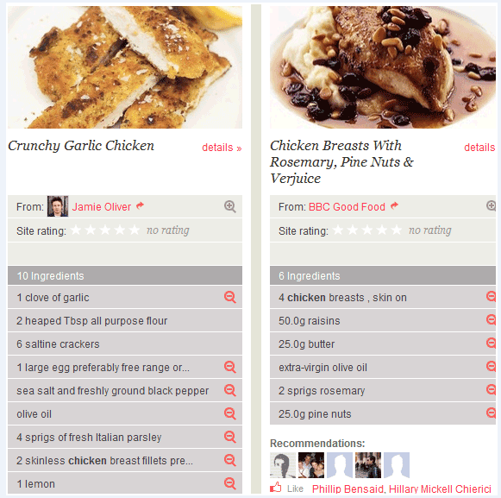

|  |
| --- |
| Main  <html>  <head>  <style>  body  {  padding-top :20px;  }  </style>  </head>  <body align="center">  <iframe src="3.1.html" width="25%" height="100%" > </iframe>  <iframe src="3.2.html" width="25%" height="100%"> </iframe>  </body>  </html> |
| <html>  <head>  <style>  .heading  {  background-color:lightgrey;  height :20px;  }  .topic  {  background-color:rgb(167, 166, 179);  }  .main  {  background-color:rgb(189, 186, 225);  }  </style>  </head>  <body>  <img src="chicken.jpg" width="100%" height="30%">  <table>  <tr>  <td> <h2> Crunchy Garlic Chicken </h2> </td>  <td> <font color="red"> details </font> </td>  </tr>  </table>  <table rowspan="13">  <tr><td class="heading">From : <font color="red"> Jamie Oliver </font> </td></tr>  <tr><td class="heading"> Site rating : ✰ ✰ ✰ ✰ ✰ <i> no rating </i> </td>  <tr><td class="heading"> </td> </tr>  <tr><td class="topic"> 10 Ingrediants </td></tr>  <tr><td class="main"> 1 clove of garlic </td></tr>  <tr><td class="main"> 2 headped tbsp all purpose flour </td></tr>  <tr><td class="main" > 6 saltline crackers</td></tr>  <tr><td class="main" > 1 large egg preferably free range </td></tr>  <tr><td class="main"> sea salt and freshly ground black pepper </td></tr>  <tr><td class="main"> olive oil </td></tr>  <tr><td class="main"> 4 spring of fresh ilatlian parshey</td></tr>  <tr><td class="main"> 2 skinless chicken </td></tr>  <tr><td class="main"> 1 lemon</td> </tr>  </table>  </body>  </html> |
| <html>  <head>  <style>  .heading  {  background-color:lightgrey;  height :20px;  }  .topic  {  background-color:rgb(167, 166, 179);  }  .main  {  background-color:rgb(189, 186, 225);  }  </style>  </head>  <body>  <img src="chickenbreast.jpg" width="100%" height="30%">  <table colspan="3">  <tr>  <td> <h2> <i> Chicken Breasts With <br> Rosemary , Pine Nuts & <br> Verjuice </i> </h2> </td>  <td> <font color="red"> details </font></td>  </tr>  </table>  <table rowspan="10">  <tr><td class="heading"> From : <font color="red"> BBC good Food </font> </td></tr>  <tr><td class="heading"> Site rating : ✰ ✰ ✰ ✰ ✰ <i> no rating </i> </td>  <tr><td class="heading"> </td> </tr>  <tr><td class="topic"> 6 Ingrediants </td></tr>  <tr><td class="main"> 4 Chicken breast </td></tr>  <tr><td class="main"> 50.0g raisins </td></tr>  <tr><td class="main" > 25.0g Butter</td></tr>  <tr><td class="main" > extra-virging olive oil </td></tr>  <tr><td class="main"> 2 springs rosemary </td></tr>  <tr><td class="main"> 25.0g pine nuts</td></tr>  </table>  <h3> <font color ="grey"> Recommendations </font> </h3>  <img src="person1.png" width="20%" height="10%"> <img src="person2.png" width="20%" height="10%"> <img src="person3.png" width="20%" height="10%">  <p> Like <font color ="red"> Phillip Bensaid , Hillary Mickell Chierici </font> </p>  </body>  </html> |
|  |

1. **Other frame templates.**

Students can fit in their interested data in the formats and design HTML pages

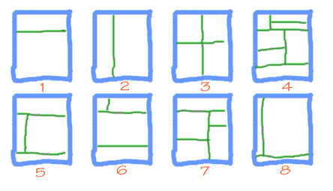

|  |  |
| --- | --- |
| ***Q3***  <html>  <style>  .box{  display: grid;  height: 90%;  }  .box1{  display: flex;  height: 100%;  }  .box2{  display: flex;  height: 100%;  }  </style>  <body>  <div class = "box">  <div class = "box1">  <iframe src = "griffendor.html" width="50%"></iframe>  <iframe src = "slytherin.html" width = "50%"></iframe>  </div>  <div class = "box2">  <iframe src = "ravenclaw.html" width="50%"></iframe>  <iframe src = "hufflepuff.html" width = "50%"></iframe>  </div>  </div>  </body>  </html> | |
| <html>  <style>  p  {  font-family:arial ;  font-size:50px;  }  </style>  <body>  <table>  <tr>  <td><img src="griffindor.jpg"></td>  <td><p>  <a href="https://harrypotter.fandom.com/wiki/Gryffindor"> GRYFFINDOR </a> </p></td>  </tr>  </table>  </body>  </html> | <html>  <style>  .box{  display: grid;  height: 90%;  }  .box1{  display: flex;  height: 100%;  }  .box2{  display: flex;  height: 100%;  }  </style>  <body>  <div class = "box">  <div class = "box1">  <iframe src = "griffendor.html" width="50%"></iframe>  <iframe src = "slytherin.html" width = "50%"></iframe>  </div>  <div class = "box2">  <iframe src = "ravenclaw.html" width="50%"></iframe>  <iframe src = "hufflepuff.html" width = "50%"></iframe>  </div>  </div>  </body>  </html> |
| <html>  <style>  p  {  font-family:arial ;  font-size:50px;  }  </style>  <body>  <table>  <tr>  <td><img src="hufflepuff.jpg"></td>  <td><p>  <a href="https://harrypotter.fandom.com/wiki/Hufflepuff"> HUFFLEPUFF </a> </p></td>  </tr>  </table>  </body>  </html> | <html>  <style>  p  {  font-family:arial ;  font-size:50px;  }  </style>  <body>  <table>  <tr>  <td><img src="ravenclaw.jpg"></td>  <td><p>  <a href="https://harrypotter.fandom.com/wiki/Ravenclaw"> RAVENCLAW </a> </p></td>  </tr>  </table>  </body>  </html> |
|  | |

|  |
| --- |
| ***Q6***  <html>  <style>  div{  display: flex;  height: 30%;  }  </style>  <body>  <div class = "box">  <iframe src = "griffendor.html" width="20%"></iframe>  <iframe src = "slytherin.html" width = "80%"></iframe>  </div>  <iframe src = "hufflepuff.html" height = "50%" width = "100%"></iframe>  <iframe src = "ravenclaw.html" height = "20%" width = "100%"></iframe>  </body>  </html> |
|  |

|  |
| --- |
| ***Q1***  <html>  <body>  <iframe src = "griffendor.html" width="100%" height="30%"></iframe>  <iframe src = "hufflepuff.html" width="100%" height = "100%"></iframe>  </body>  </html> |
|  |